Create an automation test system for a pure C++ component

Introduction
We need to create an automation test system for a pure C++ component.

Design Issues
There’re some principles for the automation test system.
- Internal data structure and APIs may evolve, but the Tester should have no problem to read the old test cases and replay the test.
- We should introduce as few changes as possible to for it to work with Tester.

And the design problems are
- How it write out the script file
- How the Tester replay the script
- Design a result file format
- Implement System::outputResult()
- Implement a schema language to do smoke test
- Consider the performance testing

Design Overview
This section mainly described how the transcripting capability is added to it.

We use a conditional compiled macro to encapsulate every transcripting function call in . By this method, we’ll have a “scriptable” version of this library and a normal version of it. When we want itto write/replay transcript, we’ll use the “scriptable” version. The “scriptable” libXXX.dll should be able to replace the normal libXXX.dll unconditionally. The transcripting code changes will have zero impacts to normal .dll.

At the beginning of each API function (including System::, RigidBody::, …etc), there’ll be a call TrxUtil::scriptXXX() to script the arguments passed into this API. It mainly puts the API’s argument to a character stream in a form like “h=0; useBias=true; bias1=[1.0, 0.0. 0.0]; bias2=[2.0, 0.0, 0.0]; b1 = G.2. System::createRBody.1; ….”.

Inside each API function, if it new some objects, it should register that object with the Transcript Manger. Registering means associating a unique name to the object pointer. This is required because this object is very likely to be used later in other API calls. And in those calls, we should be able to translate the object name to the real pointer. The rules to create a name will be discussed later.

Through the above steps, we should be able to create a script file.

The output file should be a text file that records the constraint solving status, body transformation matrix and constraint status. The details of the output files will be discussed later.

Data Model

Overview

We’ll define a transcripting utility class, TrxUtil, to write a scripter and parser for every API. During the lifetime of libXXX.dll, there’ll be a single ExtTranscriptManager, which takes care of all the transcripting work. The ExtTranscriptMgr is an interface that defines all the transcripting functionality needs, including the basic file stream manipulation and object pointer registration. We should define a concrete transcript manager to do the real job, which is TRMTranscriptManger. TRMTranscriptManger can hook up a parser function map and a dummy object builder to support the transcript replaying.

From the project file structure’s point of view, we’ll add a utility class, TrxUtil, and an interface classe, ExtTranscriptMgr. And we’ll create a new dll project, TRM (TRranscript Manger), which defines the concrete transcript manger, TRMTranscriptManager. Finally, we’ll create a new exe program, Tester, which will invoke and TRM to do the independent automation test. In this structure, still has no dependence to any other. Tester has dependencies to both and TRM.

We’ll have a “scriptable” version .dll side by side with the normal .dll. The “scriptable” version should be able to replace the normal version .dll unconditionally. The objective is, by replacing the normal .dll with the scriptable .dll, the application can automatically generate transcript files in a specified place. To achieve this, when the .dll loads (process attach), it’ll explicitly load trm.dll, and trm.dll will create a concrete TRMTranscriptMgr object and assign it to .dll. When the .dll unload (process detach), it’ll explicitly unload trm.dll, and then, explicitly delete the transcript manager object.

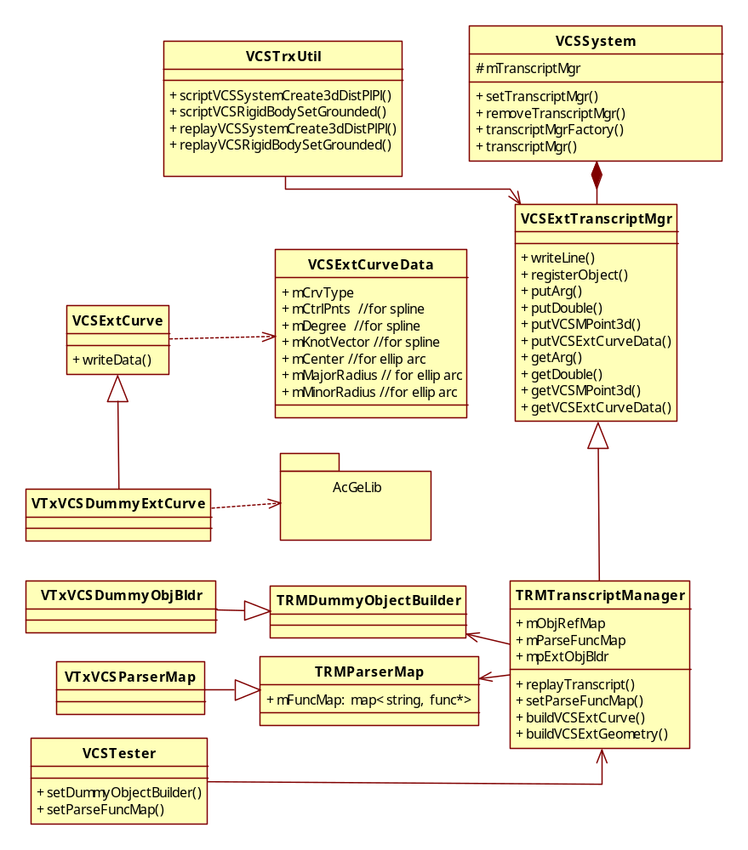
TRM
Tester

TrxUtil
This is a utility class that only contains static functions. It includes the scripter (scriptXXX) and script-parser (replayXXX) for all APIs. It’s a central place where all the transcripting related codes should be in.

Scripter functions (scriptXXX)
When we script an API function, we always need to script two arguments first. The first argument is always the parse function’s name that will be used to parse this line. The written out name should be the same with registered parse function name in the TRMParseFuncMap. The second argument is the “this” pointer of this API call. E.g, when we script System::create3dDistPlPl(), we should script the System* pointer. When we script the RigidBody::setGrounded(), we should script the RigidBody* pointer.

After script the first two arguments, we script all the passed in arguments in its order. There’re 4 situations for the input arguments:
- If the argument is a primitive data type or an object, such as double or a MPoint3d, we directly write the content to the stream.
- If the argument is a NULL pointer, we directly write “NULL”.
- If the argument is a non-NULL pointer AND is registered with the transcript manager, we write down its registered name.
- If the argument is a non-NULL pointer AND is NOT registered, we should report an error.

The scripter function is implemented by a series of macros named as BEGIN__TRX_CALL[x]. The x is the number of parameters in that API.

Some APIs are both used by applications and internal solve. However, we don’t need to write out transcript in the solve phase. So we set the System::mTranscriptingOn to false at the beginning of Sys::solve(). Every scripter function will need to check this variable before it does any transcripting.

Script-Parser functions (replayXXX)
The replay function is the reverse of the script function. It reads in a line of transcript, re-build all input-arguments for an API function, and then really call that API.

Here are the four situations for the input-arguments:
- If the argument is a primitive data type or an object such as double or MPoint3d, we can directly reconstruct the object from the script.
- If the argument is a pointer and the script content is “NULL”, directly use NULL.
- If the argument is a non-NULL pointer AND is registered, get the object from the transcript manager.
- If the argument is a non-NULL pointer AND is not registered, we should report an error.

For example,
bool TrxUtil::replay_System_create3dVariableCircle () {
System* thisPtr = NULL;
VarGeomHandle* h = NULL;
RigidBody* body = NULL;
Circle3d cir;

ExtTranscriptMgr* trxMgr = System::transcriptMgr();
trxMgr->get("thisPtr", (void*&)thisPtr);
trxMgr->get("h", (void*&)h);
trxMgr->get("body", (void*&)body);
trxMgr->get("cir", cir);

thisPtr->create3dVariableCircle(h, body, cir);
return true;
}

Example code
The below is an example of the transcripts of a program.

program:
System* pSystem = System::createSystem();

MPoint3d pt1 (0, 0, 1);
MPoint3d pt2 (0, 0, 2);
MLine3d ln (pt1, pt2);

RigidBody* pBody1 = NULL, *pBody2 = NULL;
MMatrix3d xform; MPoint3d cor;
pSystem->createRBody(pBody1, 1, xform, cor);
pSystem->createRBody(pBody2, 2, xform, cor);
pBody2->setGrounded(true);

ConHandle* h = NULL;
pSystem->create3dDistPtLn(h,false,pt1,pBody1,pBody2,pt1,ln,NULL,NULL,2.0, kEQ);

pSystem->solve();

pSystem->free();

Transcript:
1 SystemCreateSystem()
2 SytemCreateRBody(this = G1.System::createSystem.0; rBody=NULL; id=1; t=[1, 0, 0, 0], [0, 1, 0,0], [0, 0, 1, 0], [0, 0, 0, 1]; cor=[0, 0, 0])
3 SytemCreateRBody(this = G1.System::createSystem.0; rBody=NULL; id=2; t=[1, 0, 0, 0], [0, 1, 0,0], [0, 0, 1, 0], [0, 0, 0, 1]; cor=[0, 0, 0])
4 RigidBodySetGrounded(this = G3.System::createRBody.1; g = true; changeDOF = false; setChildren = false)
5 SystemCreate3dDistPtLn(this = G1.System::createSystem.0; h=NULL; useBias=false; bias=[0,0,1];b1=G2.System::createRBody.1;b2=G3.System::createRBody.1;p=[0,0,1];l=[0,0,1],[0,0,1];extG1=NULL;extG2=NULL;v=2.0;mode=0)

We’ll add a lot of these scriptXXX and replayXXX functions. But since they are quite structured, we can write a series of macros to represent the scriptXXX function. And we can use an automatic code generation tool to generate the replayXXX functions.

An example of the scriptXXX macro is:
BEGIN__TRX_CALL4(transcriptMgr(), System_createRBody, this, rBody, id, t, cor)

The macro’s definition is:
#ifdef _TRX_ON
#define BEGIN__TRX_CALL4(transMgr, APIName, thisPtr, para1, para2, para3, para4) \
transMgr->apiBegin(#APIName); \
if (transMgr->isTranscriptingOn()) { \
transMgr->beginFuncLine(); \
transMgr->putFuncName(#APIName); \
transMgr->put("thisPtr", thisPtr); \
transMgr->put(#para1, para1); \
transMgr->put(#para2, para2); \
transMgr->put(#para3, para3); \
transMgr->put(#para4, para4); \
transMgr->endFuncLine(); \
}
#else
#define BEGIN__TRX_CALL4(X)
#endif

The expansion of the above example macro is:
transcriptMgr()->apiBegin(“System_createRBody”);
if (transcriptMgr()->isTranscriptingOn()) {
transcriptMgr()->beginFuncLine();
transcriptMgr()->putFuncName(“System_createRBody”);
transcriptMgr()->put("thisPtr", thisPtr);
transcriptMgr()->put(”rBody”, rBody);
transcriptMgr()->put(”id”, id);
transcriptMgr()->put(“t”, t);
transcriptMgr()->put(“cor”, cor);
transcriptMgr()->endFuncLine();
}

An example of the replayXXX function is:
bool TrxUtil::replay_System_createRBody (ExtTranscriptMgr* trxMgr) {
System* Sys = NULL;
RigidBody* rBody = NULL;
UINT_PTR id;
MMatrix3d t;
MPoint3d cor;

trxMgr->get("thisPtr", (void*&)Sys);
trxMgr->get("rBody", (void*&)rBody);
trxMgr->get("id", id, NULL);
trxMgr->get("t", t);
trxMgr->get("cor", cor);

Sys->createRBody(rBody, id, t, cor);

return true;
}

ExtTranscriptMgr

The interface
This defines an interface of the basic transcripting capability that wants. It should have the following interfaces:

- virtual bool registerObject(const char* objName, void* obj) = 0;
- virtual void* getObject(const char* objName) = 0;
- virtual bool beginFuncLine() = 0;
- virtual bool endFuncLine() = 0;
- virtual bool putFuncName(const char* funcName) = 0;
- virtual bool putInt(const char* argName, const int& intArg) = 0;
- virtual bool getInt(const char* argName, int& intArg) = 0;

Object registering
Registering is associating a object with a unique name. The concrete transcript manager will need to develop the detailed registering schema.

Changes to API

General Changes
At the beginning of each API call, we’ll add the BEGIN__TRX_CALL macro to write out the transcript.

At the end of each API call, we develop a series of macro END__TRX_CALL[x] to register all the parameters in the API’s parameter list. The macro will differentiate if the parameter is a pointer and only register the pointers.

For example, in System::createRBody(), we’ll have the below red code added.

Status Sys::createRBody( RigidBody*& rBody,
UINT_PTR id,
const MMatrix3d& t,
const MPoint3d& cor)
{
BEGIN__TRX_CALL4(transcriptMgr(), System_createRBody, this, rBody, id, t, cor)

rBody = new LeafBody(mConSystem->universe(), id, Body::kNormal);
mConSystem->append((Body*) rBody);

Status status;
if ((status = rBody->setTransform(t)) != kOK) {
delete rBody;
return status;
}
if ((status = ((Body*) rBody)->setPublicTransform(t)) != kOK) {
delete rBody;
return status;
}

rBody->setCOR(cor);

END__TRX_CALL4(transcriptMgr(), System_createRBody, this, rBody, id, t, cor)

return kOK;
}
Please note that the code encapsulated by BEGIN and END macro will not appear in normal .dll. Hence the transcripting code has no performance impact to the normal .dll. A detailed explanation on the macro is here.

TRM
This defines a concrete transcript manager.

TRMTranscriptManager
The TRMTranscriptManager defines a concrete transcript manager that can be used by .

It defines a replayTranscript() function that just open a transcript file and parse each line of the transcript file to execute corresponding API functions. It first extracts a function name from the scripting line and then looks up the parse function map to get a parse function pointer. This mechanism is similar to Inventor’s RDxAssyConstraint::Load().

The TRM module is designed to be relatively independent, and it’s expected that with small modifications it can be used for other software’s transcripting.

The key word is:
bool TRMTranscriptManager::replayScript(const char* fileName) {
…
getParserName(lineBuf, parserName);
ParserPtr pfn = getParserPtr(parserName);
(*pfn)();
}
}
…
}

Object registering

As we said before, Registering is associating a object with a unique name.
We use a rule-based naming scheme for object’s registering. The registered name should be in a form:

G.[c1].[API_name].[c2].<optional>

For example, G.1.System::createSystem.0, G.10.System::createRBody.1.0, …, .

- “c1” is the count of all the API calls when we register the object.
- “c2” is the argument’s sequence number in the API’s formal parameter list.
  - If a object is returned from the API, the c2 is 0.
- “optional” is an optional string. It’s reserved for the cases that the first 3 item can’t uniquely name an object.
  - If an API takes an array as input, like void createMultipleBodies(Body**, ….). We define the <optional> as the object’s index in the array.

We can add more rules for <optional> in the future.

The naming only happens when we register the object. We must ensure this naming scheme is reliable and scalable. Please see the alternatives for why we use this rule-based naming scheme.

For internal objects, because they can only be created through a API, for example, the RigidBody, we register the objects in that API. In that case, the object is a parameter in the API’s parameter list. Registering internal objects in their constructors is not acceptable because future code changes could change the sequence of the constructors calling.

For external objects, we registered them in their constructor. Because the constructor is called in a fixed sequence in the transcript file, and that sequence will not be changed by the future’s code changes. So registering external object in their constructor is acceptable.

TRMParseFuncMap
This is the class to manage the parse function name and its function pointer. Most of the code can be borrowed from RDxAssyConstraintLoaderMap. But we are simpler because we only map a function name to its function pointer.

The ParseFuncMap implements operation functions like addLoader() and getLoader().

The Tester will implement a concrete parser map which just call the addLoader() to register parse functions to the transcript manager.

transcript file
The transcript file includes header and body. The header should include the following information:
- The title of this transcript file. The default is “Transcript File”
- The version of used to create this transcript
- The creation date
- The author name
- The original Inventor tf path that this test case is converted from (optional)

It should looks like:
'Transcript File
'Build Number: 0.0.0.0001Win32
'Thu Sep 17 09:48:44 2009
'User Name – gongr
'Original Inventor test: Q:\transcripts\regression\xxx\SOLVER_405168.tf

The body records the procedure the APIs called to construct a constraint system.

In the script file, there’re two types of lines. One is the comment line like the lines in the header, and another is the real function line that represents a real API call. We add a line number in front of each real function line, this will make the problem diagnosing easier.

Tester

Spec
From point of view, Tester is another application that use this library. It’s a stand-alone application which reads transcript file and replay it.

Its capability should include:
- Take a transcript file name as input, replay the transcript
- Produce the output result file
- Return an error type.

The key is:
VTxParserMap::VTxParserMap() {
ADD_PARSER(replay_System_create3dVariableCircle);
}
Where #define ADD_PARSER(X) addParser(#X, TrxUtil::X)

void TRMParserMap::addParser(const char* parseFuncName, ParserPtr pfn) {
std::string key(parseFuncName);
ParserMap::iterator iter = mParserMap.find(key);
if (iter == mParserMap.end()) {
mParserMap.insert(ParserMap::value_type(key, pfn));
}
}

Its capability shouldn’t include:
- Replay the test cases multiple times
- Compare the result file.
These capabilities should be provided by iTest.

Solve result file
This part has nothing to do with the transcripting.

The solve result file records the solve result of a System. It should be in a XML format. XML is nothing special because it’s just plain text. While with the self-explanatory tags in XML, it should be easier for us to develop tools to analyze the result file in the future. Currently Inventor also use XML format for the output.

The solve result file should include the following items:
- The version of used to create this result file.
- System:
  - The solve status
  - mSolveMode
  - mContextMode
  - mCollisionIsPossible
  - mDOF
  - mPosition
- RigidBody:
  - RigidBody::mID
  - BodyState3d::mMatrix
- Constraint:
  - ConHandle:: mType
  - (mJunction->mBody1->mID, mJunction->mBody2->mID)
  - ConHandle::mStatus
- SystemConstraint:
  - SysCon::isRelationMet()
- RigidTester
  - m_bRigid
- The sequence of the reactor firing events. (optional)

Some of the items will be written as XML attributes and some as values. The solve result file should look like:
<?xml version="1.0" encoding="utf-8"?>
<result _VERSION="0.0.0.0001Win32">
<system>
<status> kSolved </status>
<mSolveMode> kInternalOnly </mSolveMode>
<mFinishedInPhase1> true </mFinishedInPhase1>
,,, ,,,
</system>

<bodies>
<body matchID = “1” id ="1">
<t t00 = “1.0” t01 = “0.0” t02 = “0.0” … t33 = “1”> </t>
<DOF> 1T/3R </DOF>
</body>
<body matchID = “1” id ="2">
<t t00 = “1.0” t01 = “0.0” t02 = “0.0” … t33 = “1”> </t>
<DOF> 0T/2R </DOF>
</body>
,,, ,,,
</bodies>

<groupofbodies>
<group matchID = “1” >
<t t00 = “1.0” t01 = “0.0” t02 = “0.0” … t33 = “1”> </t>
<mGrounded> true </mGrounded>
</group>
,,, ,,,
</groupofbodies>

<constraints>
<constraint matchID = “1” type ="kAngVecVec3d" junction="(1, 3)">
<status> kSolved </status>
</constraint>
<constraint matchID = “2” type="kDistLnLn3d" juction="(2,3)">
<status> kSolved </status>
</constraint>
,,, ,,,
</constraints>

<systemconstraints>
<syscon>
<isRelationMet> true </isRelationMet>
</syscon>
</systemconstraints>

</result>

Working with Memory Leak

Make tests work with code coverage
It’s very easy to do memory leak test by using the tool named VLD to do memory leak check.

The detailed steps to check memory leak for
Setup environment:
- Install tool VLD
- Install tool Perl
- Enable the “VLD_FORCE_ENABLE” macro in .cpp and enable the “EnableVLDReport” macro in vTest.cpp

Run tests to create code coverage data:
- Run automation
- Run script perl Memory_leak_tool.pl to collect memory leak report The macros in , TRM, vTest and Tester
We defined a bunch of macros in , TRM, vTest and Tester to deal with special scenarios. In normal condition, all these macros definitions should be disabled. Here is a summary of their usage:

Macro name | domain | Usage | comment
_TRX_ON |  | This is to enable the transcripting capability of . | Normal .dll should disable it.
_TIMER_ON |  | This is to enable the solve time recording in the result file. | Normal .dll should disable it.
VLD_FORCE_ENABLE |  | This is to enable the VLD test for | Normal .dll should disable it.
CONVERT_INV_CASE | TRM | This is to facilitate converting the mass Inventor test cases conversion. | Normal trm.dll should disable it.
CODE_COVERAGE | Tester | Turn on this to prepare a Tester.exe for code-coverage run. | Normal Tester.exe should disable it.
DEBUG__TESTER | Tester | Turn on this to debug Tester without iTest. | Normal Tester.exe should disable it.
EnableVLDReport | vTest | Turn on this to collect VLD memory leak report | Normal vTest.exe should disable it.

Add transcripting capability to a new API

Full steps
If we want to add transcripting capability to a new API, we need to do following things:
- Add the scripter codes:
  - At the beginning of the API’s implementation, add a macro BEGIN__TRX_CALL[x] ([transcriptMgr], [API_name], this, [param_list])
the “x” is the number of parameters in the parameter list.
  - At the end of the API’s implementation, add a macro END__TRX_CALL[x] ([transcriptMgr], [API_name], this, [param_list]).
  - The use of the BEGIN and END macro should be paired. If the API has multiple returns, we need to add the END__TRX_CALL macro at each path of the return.
  - If the API has multiple implementations, we need to add the BEGIN/END macros for each implementation. For example, for RigidBody::setGrounded(), we have two implementations: Body::setGrounded() and SuperBody::setGrounded(). We need to add the macros to both functions.
  - If the API returns a pointer object, we need to register that pointer before return because that object might be passed to later API calls. For example, in RigidBody::parentBody(), we need to register the parent body before return.
- Add the parser code: add a function replay_[API_name] in the TrxUtil. We need to add codes in TrxUtil.h and TrxUtil.cpp.
- Register the parser function: add a line ADD_PARSER(replay_[API_name]) in VTxParserMap’s constructor.
- Add get/set function for the argument’s data types in ExtTranscriptManager if they’re not implemented yet.

Currently, the parser related code can be automatically added by the CodeGenerator tool.

Completing all the above steps doesn’t mean we’re done. We always have exceptions like System::solve() and System::createSystem(). So make sure we’ll do unit test for each piece of transcripting codes.

Performance Considerations
By adding the TranscriptManger::scripXXX() call at the beginning of each API call and registering the objects during the API execution might have a little performance impact to .

To eliminate the performance impact we use a conditional compiled macro to encapsulate all the scripting function calls. By this method, we’ll have a “scriptable” version of and a normal version . When we want to write some script, we’ll use the “script” version.

The macro should be defined as below:

#ifdef _TRX_ON
#define _TRX_CALL(X) (X)
#else
#define _TRX_CALL(X)
#endif

“_TRX_ON” is a symbol defined in project file.

And any transcripting related codes must be encapsulated by this macro. For example:
_TRX_CALL(TrxUtil::registerObject("System::createRBody", 1, rBody));

The BEGIN__TRX_CALL[x]and END__TRX_CALL[x] macro are defined similarily to eliminate the performance impact.

